RDU
REFERENCE

GENERAL

  - Review patient list under RDU service.
    - Review vitals / results.
    - Confirm pending tests / consults are ordered.
    - Confirm home medications / diets / DVT prophylaxis are ordered.
      - Glucose checks q6 if patient NPO.
  - RDU Phones
    - Sign into the phone with Epic log in
    - Phone passcode 6194
    - RDU APP 1 - (862) 233-0930 (Primary phone to be carried by 24/7 APP)
    - RDU APP 2- (862) 212-2560

ADMISSION

NBI Admit

- Send Epic chat to “NBI Int Med Avery” “NBI EHM Hospitalist”
- MOD
  - Epic chat “NBI Int Med Avery”
    - All unassigned patients under the age of 65 and younger
    - All clinic patients including patients over the age of 65

- Hospitalist
  - Epic chat “NBI EHM Hospitalist”
    - All unassigned patients over the age of 65
    - MOD capped
    - Private physicians do not have admitting privileges

Admission Criteria
- Epic chat “NBI ED Hurc” with patient attached
- All patients approaching 2nd midnight should be admitted, regardless of what is pending in the RDU
- Patients awaiting a cholecystectomy or appendectomy may stay under the RDU service for a second midnight pending OR
- If you get an epic chat from HURC that a patient meets admission criteria, admit the patient, except sickle cell.

Arrhythmias/Cardiology

Bradycardia
  - Bradycardia with symptoms meets admission
  - Symptoms:
    - chest pain
    - confusion
    - fatigue
    - dizziness/lightheadedness
    - syncope
    - shortness of breath

ACS
  - Acute chest pain or anginal equivalent and BOTH
    - Finding, >= One:
      - New ischemic changes on EKG
      - Troponin > ULN and > baseline
    - Intervention, >=One
      - Anticoagulation
      - Cath lab

Electrolytes

Hyponatremia
- Na 120-129
- Symptomatic
                - nausea
                - vomiting
                - confusion
                - Muscle weakness/spasms
                - seizures
Hypokalemia
  - K <= 2.5 meets admission criteria
  - K < 3.0 meets admission with symptoms or EKG changes

Hyperkalemia
  - K > 6.0

Hypercalcemia
  - Calcium 12.1-13.9 and symptomatic
  - Symptoms of Hypercalcemia
    - abdominal pain
    - mental status changes or Glasgow Coma Scale GCS 9-14
    - nausea
    - nephrolithiasis
    - vomiting
    - fatigue
    - muscle pain
    - constipation
    - arrhythmia
    - memory issues

Hypocalcemia
  - Calcium 5.0 - 7.4 mg/dL and symptomatic
  - Symptoms:
    - Muscle cramps/spasms
    - Confusion
    - Tingling in the lips and fingers
    - Muscle weakness
    - Fatigue
    - Sensation of pins and needles
Magnesium
  - Magnesium of 1.0-1.4 mg/dL (0.41-0/58 mmol/L) and symptomatic
  - Symptoms
    - Muscle weakness
    - Spasms
    - Tremors
    - Arrhythmias
    - Seizures
    - Nausea/Vomiting

Abdominal/GI Disorders

GI Bleed
- Acute >=One
  - Upper GI non-variceal bleeding and one of the following
    - coffee ground emesis, hematemesis, hematochezia, or melena and >= one
      - HCT <21% or Hbg <7.0 g/dL
      - Exertional dyspnea worse than baseline
      - INR >= 2.0
      - Mental Status Changes (excludes coma, stupor, or obtundation)
      - Syncope
      - Orthostatic hypotension, both
        - Sustained drop in blood pressure within 3 min of sitting or
        - Systolic blood pressure drop >= 20 mmHg or diastolic blood pressure drop of >= 10 mmHg

Pancreatitis
- Abdominal pain consistent with pancreatitis
  - Lipase/amylase greater than or equal to 3x ULN
  - Risk factor >= one
    - HCT>=44% after aggressive fluid resuscitation
    - Mental status change (excludes coma, stupor, or obtundation) or GCS 9-14
    - Pancreatic duct obstruction
    - Pleural effusion confirmed by imaging
    - Pulmonary infiltrate confirmed by imaging

Choledocholithiasis
- Actual or suspected + BOTH
  - Pain in RUQ +
    - CBD stone or dilation on imaging
    - Total bili >1.7, abnormal LFTs
  - MRCP performed within 24 hours

Endocrine

Hyperglycemic Crisis
- Diabetic Ketoacidosis >=One of the following
  - All
    - Blood glucose >=200 mg/dL
    - Acidosis >=one
      - Anion gap >12 mEq/L
      - Arterial or venous pH <=7.25
      - Positive ketones

Musculoskeletal

RIB FRACTURE/CHEST WALL FRACTURE
- Acute >=One
  - Musculoskeletal >= one
    - Chest wall fracture and >=One:
      - Analgesic, continuous
      - Respiratory impairment or high risk
        - Age >65 yrs and >2 rib fractures

Neurology

CVA
- Positive stroke on CT or CTA
- Negative CVA on CTA or CTA but continues to have a neurological deficit including inability to ambulate (NIH 0)

Seizure/Acute exacerbation of neurologic disorder AND
- 2 seizures within 24 hours

Toxicology

Alcohol or anxiolytic or hypnotic or sedative withdrawal syndrome
- Alcohol withdrawal syndrome and,
  - CIWA-Ar 8-14

Toxic exposure or ingestion
- Other toxic exposure or ingestion actual or SUSPECTED and ALL OF THE FOLLOWING
  - Potential for significant arrhythmia
  - EKG normal, unchanged, or nondiagnostic
  - Continuous cardiac monitoring

Anaphylaxis/Angioedema

- More than one dose of epinephrine given and/or

- Airway Compromise (scope needed for angioedema patients)

EXCLUSION
CRITERIA

Vital Signs
- HR >120
- BP >180/100
- SpO2 < 89%

Patient population
- Age <14 years old
- Pregnant >16 weeks with abdominal pain
- Acute psychosis, active suicidal/homicidal ideations
- Acutely intoxicated
- LVAD
- BIPAP/CPAP (Other than routine CPAP at night)
- Rectal Tube
- Chest tube
- NGT
- Trach needing vent
- Vented
- Pending SANE

Medication Exclusions
- Titratable drips
- Veletri gtt
- Heparin gtt
- Insulin gtt
- Lasix gtt
- NAC

Lab values
- HgB <5
- Potassium <2.5

Obtaining Bed on RDU Unit (F3)
- Heart and lung transplants indefinitely must stay in the Emergency Dept
- Renal transplant within 1 year must stay in the Emergency Dept

SOCIAL WORK AND PEER RECOVERY

Peer recovery
- If rehab or detox is being arranged for patient by the peer recovery team, patient can still be discharged pending placement/arrangement of placement
- Consult for all potential Vivitrol patients

Weekend need for TLSO brace
- discuss with social work
- call 1-800-848-8866 (AlliedOP)
- non-weekend arrange with neurosurgery APP

Physical Therapy on Weekends
- Epic chat “NBI IP Physical Therapy” at 9 am

Social work/Case management on weekdays
- Meet in the ED at 9 am
- Discuss all physical therapy cases and the need for DME, social cases/housing insecurities, those who are from a Subacute/nursing facility and will be discharged back to facility
- Medications to Bed for uninsured patients

Social work/Case Management on weekends
- Check on-call for RDU on “NBI Case Management” at 8am–get involved early for all social cases and the need for physical therapy
- Weekend supervisor Sat and Sun 8am-6pm
  - Patrick Lowe 973-274-5529
- Weekend Case Manager Sat and Sun 8am-4pm
  - Stephen Dabreo 908-577-4983

Need for Home Oxygen
- 6 minute walk test done in pulmonology (on their floor) (results often put in paper chart)
- Have social on-board to arrange home O2

Palliative Care Consults
- Get case management/social worker involved
- Nancy PA-C 732-539-6130
- Susan 848-303-4003

RDU DISPOSITIONS

Able to Return to the RDU
- Dental
- Upper endoscopy
- Colonoscopy
- Cardioversion in Cardiac Non-invasive (Not cath lab)
- TEE
- Stress tests
- Dialysis
- Radiation treatment

Does not return to the RDU after
- Anything requiring OR and PACU time (all surgical cases)
- Cardiac catheterization
- ERCP (only performed by Dr. Cabaleiro)
- Fistulogram

Meds to Bed on Weekend
- Jnaya 11am-3pm on Saturdays 908-577-8924
  - Need paper script

Charity Care
- Phone number 856-330-8209

Community Health Workers
- Help with insurance, follow up appointments, SDOH
  - Work on F3 now and get triggered based on pt information

Patient Navigators
  - Make follow up appointments for patients, send some info about why they need follow up (i.e. G1P0, LMP 7/10/2025, ℅ vaginal bleeding, has no OBGYN)
  - AHC: Nichole Louise Drew
    - Send Epic Chat
  - WHC: Stacey Lewis
    - Send Epic chat

Ambulatory referral to Oncology
    - Order on Dispo page
    - Provide information about type/location of CA so they can arrange f/u with correct provider

Cardiology
Testing/Results/Times Consults

Vascular Results & Times

Cardiology
Testing/Results/Times Consults

Confirm with cardiologist what tests they want done on their patient (echo, NM ST, CTCA). Cardiologist have to read echos on their private patients, and if they don’t know it was ordered, they won’t read it. Please call private cardiologist once echo is done to have it read. Please refer to On-Call Finder for non-private patients for echos and CTCAs to be read. Echo on-call under “NBI Card Non-Inv RDU TTE TEE” and CTCA under “NBI Card non-inv CT”. NM ST are read in a very timely manner.

Echos must be read by cardiology on call finder - NBI Card Non-Inv RDU TTE
- Weekends: NBI Card Non-Inv WKND TTE
- Message by 4 pm the latest
- **UNLESS THEY HAVE A PRIVATE CARDIOLOGIST**
    - Bobby (Dr. Nnaoma)
    - Chirag Patel
    - Sunil Patel
    - Campbell (call and ask)
    - Kaid (call and ask)

Nuclear Stress Test
- Must have potassium level >3.4
- Must have two documented troponins during current visit

CT Coronary involves 2 separate reads, one by cardiology (coronary) and one radiology (Chest findings)
- Contact on-call “NBI Card Non-Inv CT” for cardiology read

Heart failure/transplant patients
  - Epic chat “NBI Advanced Heart Failure Service” at 8 am

AICD Interrogation
- Medtronic: Text Steven D’Arco at 908-510-0095 for results after interrogation

Cardiac Testing Times

Modality | M-F | Sat, Sun
ECHO | 8AM-5PM | 8AM-4PM
Exercise Stress Test | 8AM-5PM | N/A
Stress ECHO | 8AM-5PM | N/A
Nuclear Stress Test | 8AM-12PM | N/A
Coronary CTA | 8AM-4PM | N/A

Vascular Results & Times

Pulmonary Embolism as Diagnosis
- Call PE team (on-call finder either Vascular surgery or Cardiology)
- Thrombectomy vs EKOS
- If patient has a private cardiologist - still reach out to the ON-CALL PE Team

Vascular Times
- Weekdays: Open 8am-4pm
- Weekends: On-call 8a-12p
  - Call Operator “0” to call in vasc tech @8am
  - Arterial duplex on weekends must be ordered by vascular surgery

PATHWAYS AND WORKFLOWS

CHF RDU PROTOCOL

ED requirements PRIOR to RDU:
- US is performed–8 section clips and signed off on by attending so RDU can follow
- Labs resulted
- Appropriate dosage of Lasix given
- 2hr Urine Na is ordered for 2 hours after Lasix order placed
- Initial weight accurately documented
- Cardiology has been consulted
- IV access established

Orders needed for the RDU:
- Daily weight checks
- All home meds (continue cardiac meds + any recs from Cards)
- Urine Na (2h after Lasix given)
- I&O
- 2nd trop if 1st normal
- Cardio consult
- Dietary consult
- 2g Na diet
- Fluid restriction order
  - 2L/day if Urine NA > 131, unless Na <131 (1.5L/day)
- Cardiac monitoring with pulse ox
- VTE
- 2x home dose of Lasix for 2 doses (8-12 hours apart), followed by home dose (IV) q12 hours
  - Goal: >250 ml/hr of urine output first two hours (normal renal function) or
  - Goal: >125 ml/hr of urine output first two hours (renal insufficiency)
- Daily labs: BNP, BMP, Mg
- At discharge, click “CHF Discharge Follow-up Appointments”

Points to Consider:
- Control BP!!
  - Optimize home medications with a goal BP < 130/80 mmHg in those with hypertension
    - ACE, ARB, BetaBlocker
- Perform thorough medication reconciliation and identify any potential medication triggers of acute decompensated heart failure (e.g. NSAIDs, calcium channel blocker if EF< 40%, Actos/Avandia, gabapentin).
- Make sure patients weight is performed accurately (pt in gown)
- If no obvious inciting event and no echocardiogram within six months, consider transthoracic echocardiogram
- If known EF < 30%, consult advanced heart failure team
- K+ replacement > 3.9
- Mg++ replacement > 1.9

DISPOSITION

Disposition planning:
- Risk factor modification (smoking cessation, dietary recommendations, medication compliance, monitor weight at home)
- Heart failure education (may have brochure coming)
- Case management evaluation for home care and arrangement for a home scale if needed
Consider HOME if:
- Improvement in symptoms with ability to lay flat and ambulate without recurrent symptoms or hypoxia (if ambulatory). 3 min walk without worsening baseline symptoms
- No significant alterations in baseline serum chemistries (particularly Na and Cr)
- Discussions with cards team:
  - Outpatient follow up timing and location
  - Transition from IV to oral medications and appropriate med reconciliation has been completed
  - ACEI or ARB for patients with systolic dysfunction without AKI
  - Once the patient is not acutely decompensated ensure beta blocker use for systolic dysfunction (EF < 40%, only Coreg (carvedilol), Zebeta© (bisoprolol) or Toprol XL/CR© (metoprolol) proven to reduce mortality)
- Repeat Lung US (decreased B-lines), before discharging the patient home (if not earlier in the RDU course as well)
- Reason for exacerbation has been addressed
ADMISSION
- Criteria for discharge have not been met or will cross 2nd MN.
- Worsening clinical picture despite appropriate therapy
- No or minimal response to OU therapy
- Requiring vasoactive infusion (e.g. milrinone)

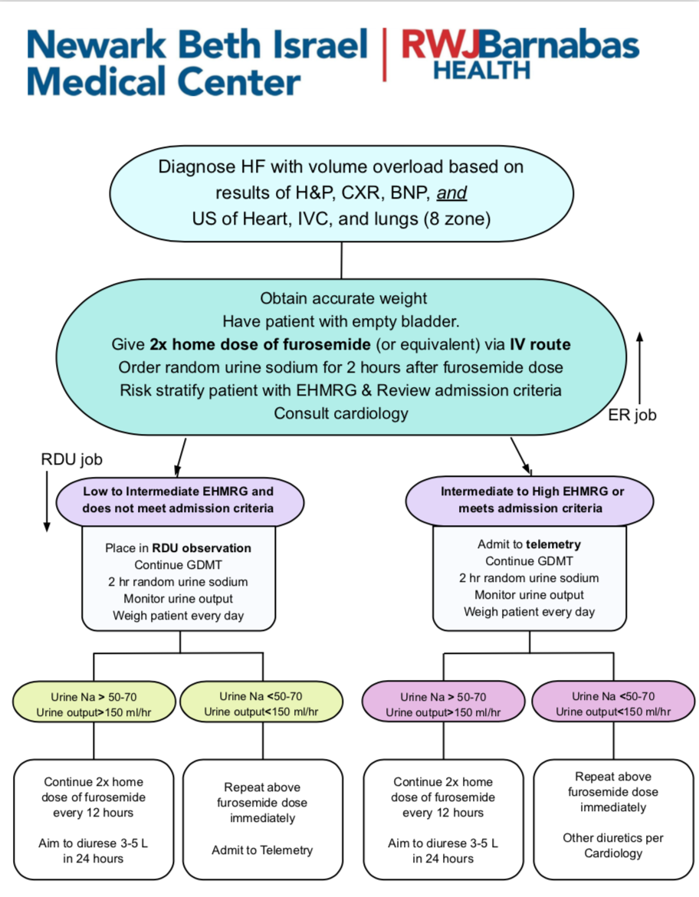
\

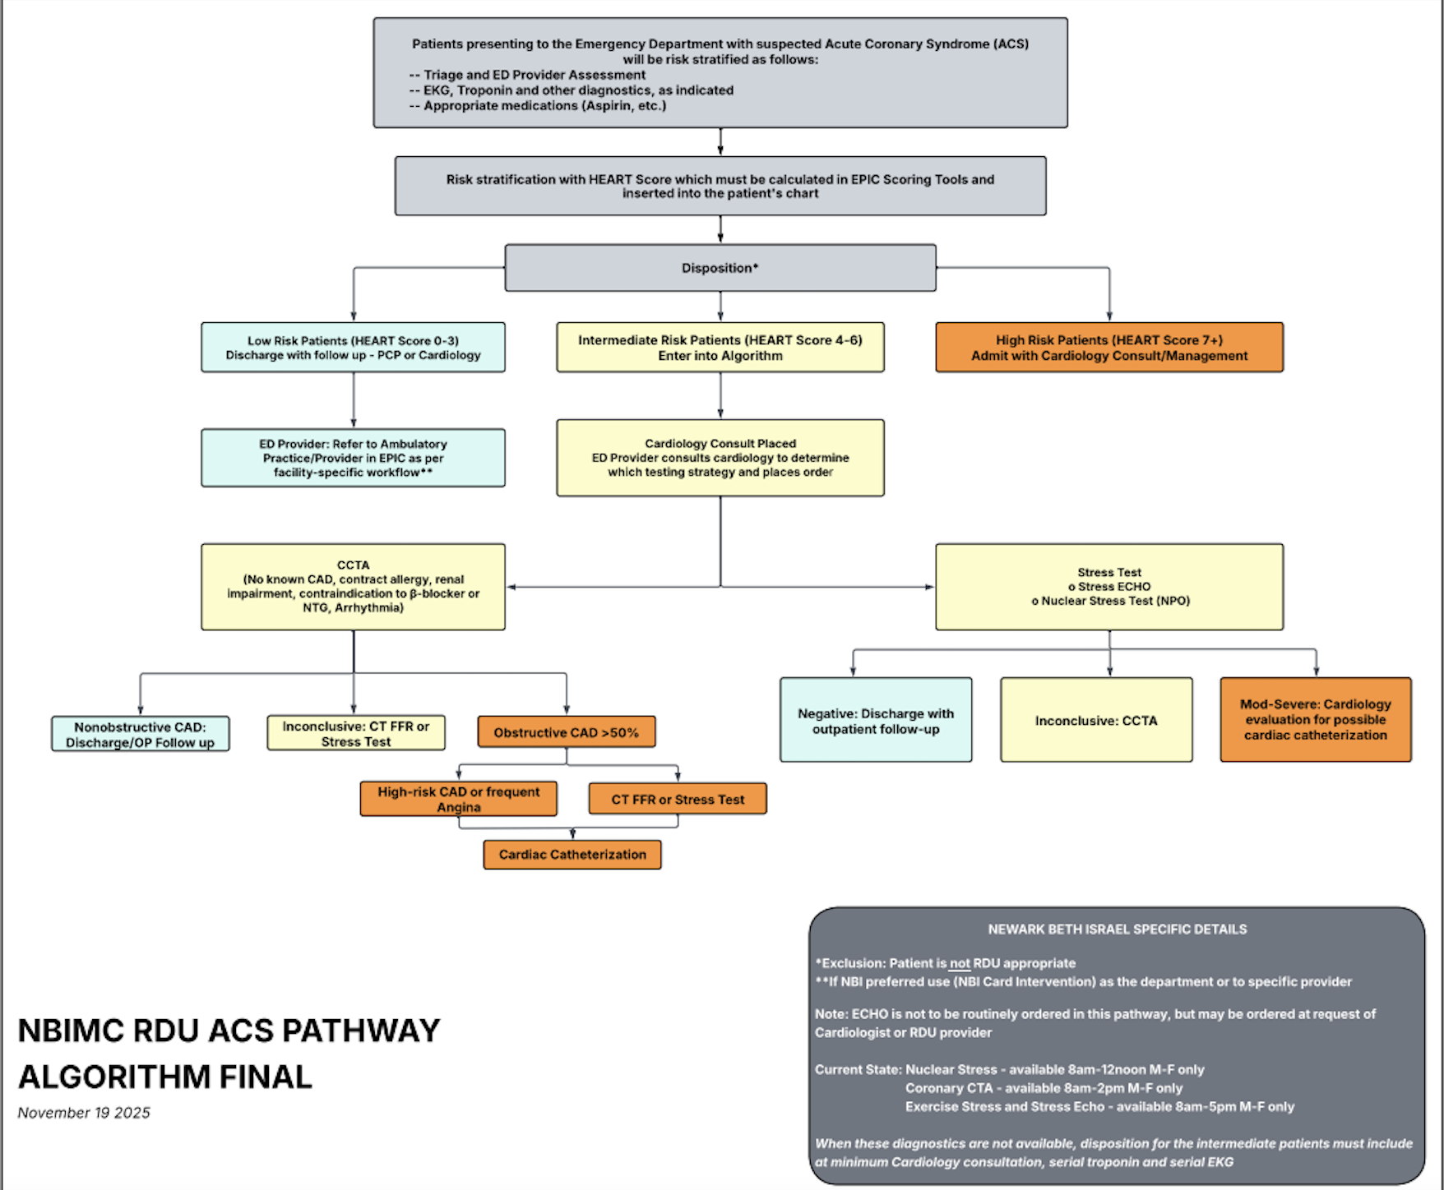

ACS RDU WORKFLOW

RDU Workflow
When patient is placed in RDU
- Add diagnosis of chest pain if following the pathway
- Make sure HEART score tool is completed
- Cardiology consult placed
- Order testing modality (CTCA or NM ST)
- Discharge with Ambulatory referral to cardiology

Checklist per HEART score category
HEART score 1-3
- Discharge with Ambulatory referral to cardiology
HEART score 4-6
- Cardiology consult placed
- NM ST or CTCA ordered
- Discharge with Ambulatory referral to cardiology
HEART score 7
- Cardiology consult before RDU placement
  - Negative troponin or baseline with no delta
- NM ST or CTCA ordered
- Dispo plan made with cardiology


RDU SICKLE CELL WORKFLOW

For the ED Team–prior to EPIC chatting RDU:
- Patient’s ED Care Plan followed by ED team, including labs, CMP, d bili, LDH, electrophoresis, etc.
- IV access must be established
- Labs must be resulted, excluding electrophoresis
- Pt has uncomplicated acute VOC & does not meet any RDU exclusion criteria outlined below

- Epic chat received from ED about SCC
- Initial RDU process
- PCA/medication regimen and fluids ordered as per ED care plan
- Daily labs ordered (CBC, CMP, Direct Bili, LDH)
- Do not place heme consult, instead EPIC chat Yvette Murillo and Alice Cohen with the pt info to notify them of RDU acceptance–they will round every morning around 7:30am
- VTE prophylaxis with Lovenox
- Continue home maintenance meds–hydroxyurea, folic acid, bowel regimen, as well as long acting PO opiates (ex. Methadone)
3a. Patient ready for DC
- Pt feeling better–no need to taper the PCA or transition to PO dosing
- Outpatient pain medication prescribed only by the heme/sickle cell team
3b. Patient requires admission
- In advance of second midnight
- Develops any condition that makes them no longer a simple acute VOC
- Only admitted to hospitalist or private physician (no MOD)

RDU Exclusion list for SCC
- Anemia requiring transfusion
- PE rule outs
- Priapism
- Headaches
- Unstable: acute chest, CVA, fever/sepsis, AMS, hypoxia, splenic/hepatic sequestration, visual changes
- Non-clinic patients
- ANYONE with a CLOVER alert MUST stay in the ED and CANNOT come to the RDU

Other RDU SC points
- Exchange transfusions only to be ordered by heme fellow–on-call 24 hours
- Concern for acute chest developing:
  - Ensure there is an active Type and Screen result (within 3 days)--necessary for exchange transfusion
  - If pt complains of chest pain, always order CXR, T&S, close pulse ox monitoring
- Alice Cohen is off Tuesdays, Yvette in-house ~7a-4p M-F
- Yvette Murillo’s (sickle cell NP) contact info: x66527 | 201-407-4258 (cell)
- Dr. Mullick and NP Dennis Kordie Hospitalist team available for questions/consults
- Heme clinic attendings: Shah x2, Cohen, Jacoby, Schleicher, Cheng–all other SC patients get admitted to hospitalist

